import pandas as pd #For Data manipulation and analysis
import matplotlib.pyplot as plt # For Plotting plots
import seaborn as sns # for visualizations based on Statistics
import numpy as np # for mathematical computing
import datetime as dt # For working with dates and times
from sklearn.feature_extraction.text import CountVectorizer, TfidfVectorizer # for converting text data into numerical vectors
from sklearn.model_selection import train_test_split # for splitting data into training and test sets
from wordcloud import WordCloud # Importing tool for generating word clouds from text data
from sklearn.decomposition import TruncatedSVD # for dimensionality reduction of sparse matrices
import re # for regular expression operations in text processing
#reading the csv file using pandas read_csv function
df = pd.read_csv('sentiment analysis dataset.csv' , encoding='latin1') # encoding='latin1' to bypass encoding issues
# df= pd.read_csv('C:\\Users\\Administrator\\Downloads\\sentiment.txt',encoding='latin1')
# Printing the shape of our dataset
df.shape
(1599999, 6)

We have 1.6m Observations and 6 features
As we can see there is not proper column name for the dataset. So we start by naming the columns first based on our understanding of the dataset
# Rename the columns for better understanding
df.columns = ['sentiment', 'id', 'date', 'query', 'username', 'text']
# Display the first few rows of the data frame
df.columns
Index(['sentiment', 'id', 'date', 'query', 'username', 'text'], dtype='object')
#Checking for Missing values:
df.isnull().sum()
sentiment 0
id 0
date 0
query 0
username 0
text 0
dtype: int64
#No missing values in our dataset

For sentiment analysis, we dont need columns such as id, date, query and username as we are merely analyzing the sentiments.

But lets gothrough each column to see if there is any usefulness
ID: Unique identifier for every tweets but it does not provide any information related to sentiment analysis. Date: Date in general can provide patterns or trends, but it doesnt have any influence the sentiment of the tweet itself. Username: Username can provide information about the author of the tweet, but it doesn't have any relevance to the sentiments in the tweet.
df['query'].value_counts()
query
NO_QUERY 1599999
Name: count, dtype: int64

Query column is filled with "NO_QUERY", which shows that there are no special queries associated with the tweet.
# Remove unnecessary columns
df = df.drop(['id', 'date', 'query', 'username'], axis=1)

Preprocessing the text
# Removing the unwanted symbols and punctuations that won't provide any info for our analysis
def text_preprocessing(text):
text = re.sub(r'http\S+', '', text) # Remove URLs
text = re.sub(r'@\w+', '', text) # Remove mentions
text = re.sub(r'#\w+', '', text) # Remove hashtags
text = re.sub(r'[^\w\s]', '', text) # Remove punctuation
text = text.lower() # Convert to lowercase
return text
# Apply the preprocessing function
df['text'] = df['text'].apply(text_preprocessing)
df.value_counts()
sentiment text
4 thanks 1661
0 1389
4 1163
thank you 1070
get 100 followers a day using wwwtweeteraddercom once you add everyone you are on the train or pay vip 830
...
0 is gutted about that new moon nowedultimatumspoiler but still wants you to follow amp 1
is gutted about katie amp peter love them 1
is gutted about city goin down 1
is gutted x 1
4 ùùùø ùùùø ù
øªø¹ø øùùùùø øøùøù ùùù øªøùù øùùùùø øªùùø øøùù øøùø¹ ù øùùø øø³ øøøùùø øø¹ùø ø¹ù øùø³øøøauthor c 1
Name: count, Length: 1535476, dtype: int64

Dataset has been successfully cleaned

Exploratory Data analysis
#Checking for the number of unique values
df.nunique()
sentiment 2
text 1531772
dtype: int64
#As we can see, there are only 2 unique values for sentiment which can be the sentiment ratio.
# Plotting a bargraph to see the sentiment distribution
plt.figure(figsize=(8, 6))
sns.countplot(x='sentiment', data=df)
plt.title('Sentiment Distribution')
plt.xlabel('Sentiment')
plt.ylabel('Count')
plt.show()
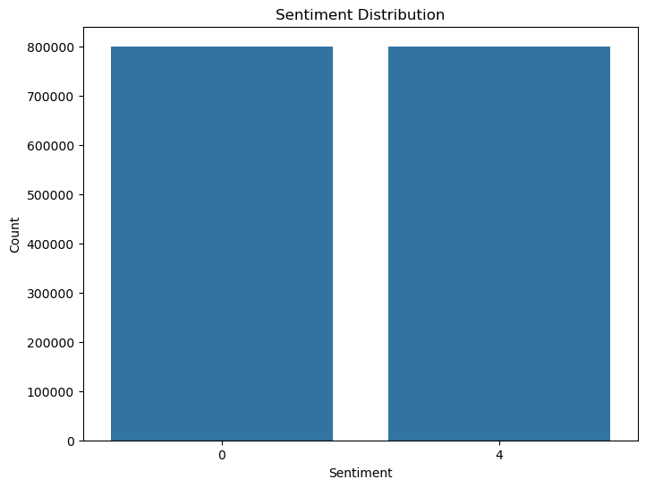

From this bargraph we can see that the tweets are evenly distributed towards postive sentiment(4) and negative sentiment(0)
#Lets Visualize the tweet length distribution
df['text_length'] = df['text'].apply(len)
plt.figure(figsize=(12, 6))
sns.histplot(df[df['sentiment'] == 4]['text_length'], bins=50, color='green', kde=True, label='Positive')
sns.histplot(df[df['sentiment'] == 0]['text_length'], bins=50, color='red', kde=True, label='Negative')
plt.legend()
plt.title('Tweet Length Distribution by Sentiment')
plt.xlabel('Tweet Length')
plt.ylabel('Frequency')
plt.show()
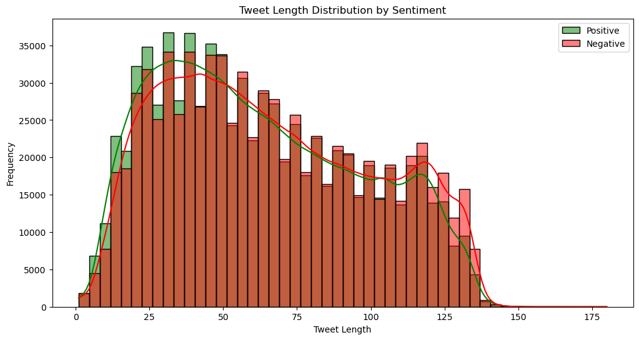

The tweet distribution shows that shorter tweets (around 20-50 characters) are more common for both positive and negative sentiments, but negative tweets tend to have a slightly higher frequency at most lengths, particularly in the 50-100 character range.
## Correlation heatmap
plt.figure(figsize=(8, 6))
sns.heatmap(df[['sentiment', 'text_length']].corr(), annot=True, cmap='coolwarm')
plt.title('Correlation Heatmap')
plt.show()
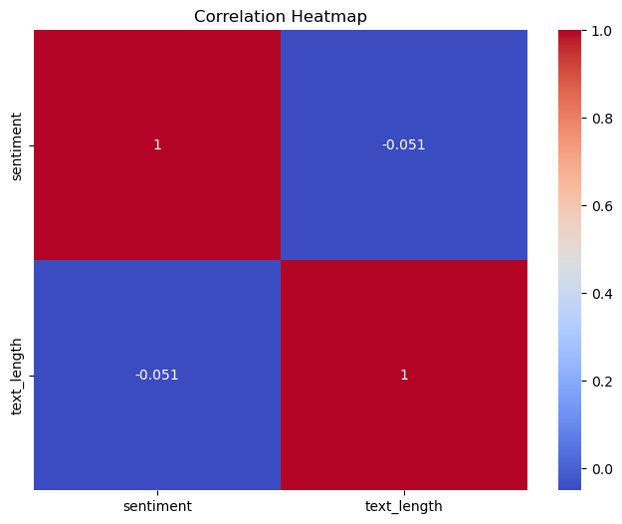

X - Length of tweets in characters , Y - Number of tweets that falls under a particular length

The distribution of tweet lengths is similar both sentiments suggesting that length alone cannot indicate the sentiments.

Word Cloud

Using WordCloud to understand the common words to learn the sentiments behind each word
# Generating word cloud for positive sentiments
positive_text = ' '.join(df[df['sentiment'] == 4]['text'])
positive_wordcloud = WordCloud(width=800, height=400, max_font_size=100, background_color='white').generate(positive_text)
# Generating word cloud for negative sentiments
negative_text = ' '.join(df[df['sentiment'] == 0]['text'])
negative_wordcloud = WordCloud(width=800, height=400, max_font_size=100, background_color='black').generate(negative_text)
# Displaying the word cloud for positive sentiment
plt.figure(figsize=(15, 7))
plt.subplot(1, 2, 1)
plt.imshow(positive_wordcloud, interpolation='bilinear')
plt.title('Positive Sentiments')
plt.axis('off')
# Displaying the word cloud for negative sentiment
plt.subplot(1, 2, 2)
plt.imshow(negative_wordcloud, interpolation='bilinear')
plt.title('Negative Sentiments')
plt.axis('off')
plt.show()
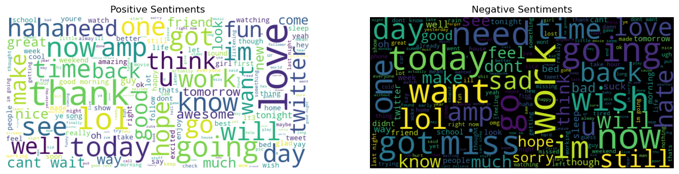
# Unigrams and Bigrams Analysis
def get_top_ngrams(corpus, n=None, ngram_range=(1, 1)):
vec = CountVectorizer(ngram_range=ngram_range).fit(corpus)
bag_of_words = vec.transform(corpus)
sum_words = bag_of_words.sum(axis=0)
words_freq = [(word, sum_words[0, idx]) for word, idx in vec.vocabulary_.items()]
words_freq = sorted(words_freq, key = lambda x: x[1], reverse=True)
return words_freq[:n]
# Getting the most commonly used unigrams and bigrams
top_unigrams = get_top_ngrams(df['text'], n=20, ngram_range=(1, 1))
top_bigrams = get_top_ngrams(df['text'], n=20, ngram_range=(2, 2))
# Converting the data into DataFrame for better visualization
df_unigrams = pd.DataFrame(top_unigrams, columns=['Unigram', 'Frequency'])
df_bigrams = pd.DataFrame(top_bigrams, columns=['Bigram', 'Frequency'])
# Plot the most common unigrams
plt.figure(figsize=(10, 6))
sns.barplot(x='Frequency', y='Unigram', data=df_unigrams, palette='viridis')
plt.title('Top 20 Unigrams')
plt.xlabel('Frequency')
plt.ylabel('Unigram')
plt.show()
C:\Users\balav\AppData\Local\Temp\ipykernel_24516\994493835.py:3: FutureWarning:
Passing `palette` without assigning `hue` is deprecated and will be removed in v0.14.0. Assign the `y` variable to `hue` and set `legend=False` for the same effect.
sns.barplot(x='Frequency', y='Unigram', data=df_unigrams, palette='viridis')
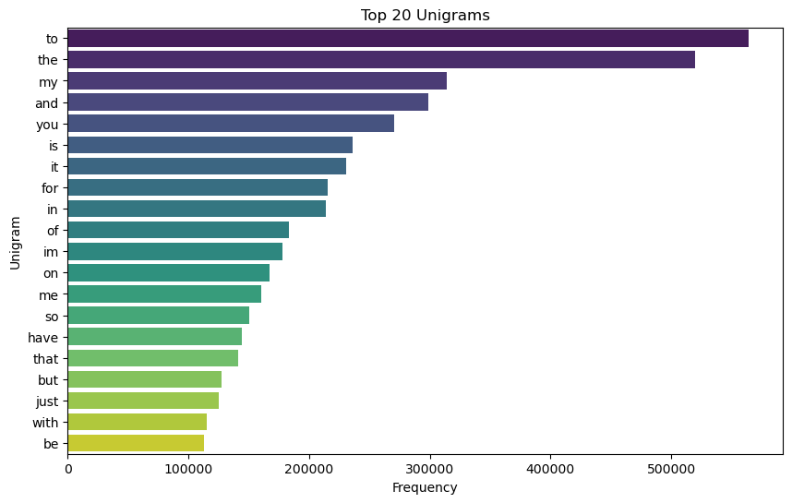
# Plotting the most common bigrams
plt.figure(figsize=(10, 6))
sns.barplot(x='Frequency', y='Bigram', data=df_bigrams, palette='viridis')
plt.title('Top 20 Bigrams')
plt.xlabel('Frequency')
plt.ylabel('Bigram')
plt.show()
C:\Users\balav\AppData\Local\Temp\ipykernel_24516\2263358691.py:3: FutureWarning:
Passing `palette` without assigning `hue` is deprecated and will be removed in v0.14.0. Assign the `y` variable to `hue` and set `legend=False` for the same effect.
sns.barplot(x='Frequency', y='Bigram', data=df_bigrams, palette='viridis')
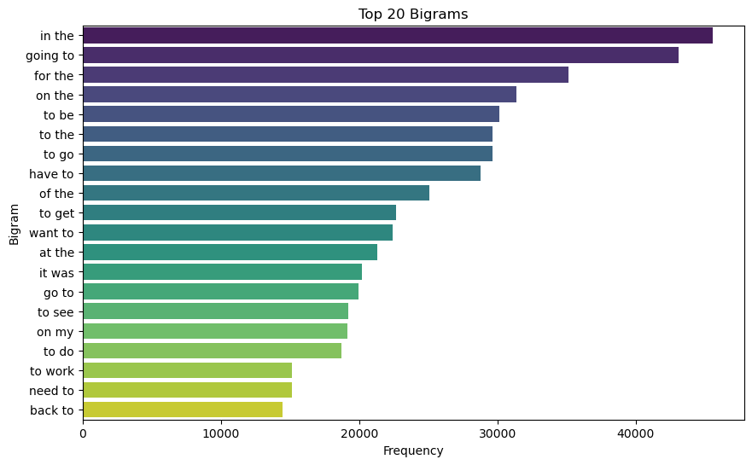

Red - Positive Correlation , Blue - Negative Correlation

A vlaue of -0.051 shows that there is linear correlation between Sentiment and text_length

Data Preparation
# Shuffle the data
data = df.sample(frac=1, random_state=0).reset_index(drop=True)
# Filter the data to get 10000 entries for each class (0 and 4)
data_class_0 = data[data['sentiment'] == 0].sample(n=100000, random_state=0)
data_class_1 = data[data['sentiment'] == 4].sample(n=100000, random_state=0)
# Combine the samples and shuffle again
sampled_data = pd.concat([data_class_0, data_class_1]).sample(frac=1, random_state=0).reset_index(drop=True)
# Preprocess the text data
X = sampled_data['text']
y = sampled_data['sentiment']
# Ensure y is a one-dimensional array
y = y.values.ravel()
# Split the data into training and testing sets
X_train, X_test, y_train, y_test = train_test_split(X, y, test_size=0.2, random_state=0)
# Display shapes of the resulting datasets
print(X_train.shape, X_test.shape, y_train.shape, y_test.shape)
(160000,) (40000,) (160000,) (40000,)

Feature Extraction
# Convert text data into numerical data using TfidfVectorizer
tfidf_vector = TfidfVectorizer(max_features=50000, ngram_range=(1, 1))
X_train_tfidf = tfidf_vector.fit_transform(X_train)
X_test_tfidf = tfidf_vector.transform(X_test)
# Display shapes of the resulting datasets
print(X_train.shape, X_test.shape, y_train.shape, y_test.shape)
(160000,) (40000,) (160000,) (40000,)

Model Training

Lets train few machine learning models to evaluate their performance
from sklearn.naive_bayes import MultinomialNB # Importing Naive Bayes classifier for multinomially distributed data
from sklearn.linear_model import LogisticRegression # Importing Logistic Regression model
from sklearn.ensemble import RandomForestClassifier # Importing Random Forest classifier for ensemble-based classification
from sklearn.metrics import classification_report, accuracy_score # for generating classification report and calculating accuracy score
from sklearn.svm import SVC # Importing Support Vector Classifier for classification tasks
from sklearn.ensemble import GradientBoostingClassifier # Importing Gradient Boosting

Naive Bayes
# Naive Bayes
nb_model = MultinomialNB()
nb_model.fit(X_train_tfidf, y_train)
nb_pred = nb_model.predict(X_test_tfidf)
# Print evaluation results for Naive Bayes
nb_accuracy = accuracy_score(y_test, nb_pred)
print(f'Naive Bayes Accuracy: {nb_accuracy}')
print(classification_report(y_test, nb_pred))
Naive Bayes Accuracy: 0.764975
precision recall f1-score support
0 0.76 0.79 0.77 20180
4 0.77 0.74 0.76 19820
accuracy 0.76 40000
macro avg 0.77 0.76 0.76 40000
weighted avg 0.77 0.76 0.76 40000

Logistic regression
# Logistic Regression
lr_model = LogisticRegression(max_iter=1000)
lr_model.fit(X_train_tfidf, y_train)
lr_pred = lr_model.predict(X_test_tfidf)
# Print evaluation results for Logistic Regression
lr_accuracy = accuracy_score(y_test, lr_pred)
print(f'Logistic Regression Accuracy: {lr_accuracy}')
print(classification_report(y_test, lr_pred))
Logistic Regression Accuracy: 0.786975
precision recall f1-score support
0 0.80 0.78 0.79 20180
4 0.78 0.80 0.79 19820
accuracy 0.79 40000
macro avg 0.79 0.79 0.79 40000
weighted avg 0.79 0.79 0.79 40000
# Random Forest
rf_model = RandomForestClassifier(n_estimators=100)
rf_model.fit(X_train_tfidf, y_train)
rf_pred = rf_model.predict(X_test_tfidf)
# Print evaluation results for Random Forest
rf_accuracy = accuracy_score(y_test, rf_pred)
print(f'Random Forest Accuracy: {rf_accuracy}')
print(classification_report(y_test, rf_pred))
Random Forest Accuracy: 0.77475
precision recall f1-score support
0 0.77 0.80 0.78 20180
4 0.78 0.75 0.77 19820
accuracy 0.77 40000
macro avg 0.78 0.77 0.77 40000
weighted avg 0.78 0.77 0.77 40000
from sklearn.ensemble import GradientBoostingClassifier
# Gradient Boosting
gb_model = GradientBoostingClassifier()
gb_model.fit(X_train_tfidf, y_train)
gb_pred = gb_model.predict(X_test_tfidf)
# Print evaluation results for Gradient Boosting
gb_accuracy = accuracy_score(y_test, gb_pred)
print(f'Gradient Boosting Accuracy: {gb_accuracy}')
print(classification_report(y_test, gb_pred))
Gradient Boosting Accuracy: 0.701625
precision recall f1-score support
0 0.75 0.62 0.68 20180
4 0.67 0.79 0.72 19820
accuracy 0.70 40000
macro avg 0.71 0.70 0.70 40000
weighted avg 0.71 0.70 0.70 40000

Model Evaluation
# Evaluate models
models = {
'Naive Bayes': nb_pred,
'Logistic Regression': lr_pred,
'Gradient Boosting Classifier': gb_pred,
'Random Forest': rf_pred
}
for model_name, predictions in models.items():
accuracy = accuracy_score(y_test, predictions)
print(f'{model_name} Accuracy: {accuracy}')
print(classification_report(y_test, predictions))
# Select the best model
accuracies = {model_name: accuracy_score(y_test, predictions) for model_name, predictions in models.items()}
best_model = max(accuracies, key=accuracies.get)
print(f'The best model is: {best_model}')
Naive Bayes Accuracy: 0.764975
precision recall f1-score support
0 0.76 0.79 0.77 20180
4 0.77 0.74 0.76 19820
accuracy 0.76 40000
macro avg 0.77 0.76 0.76 40000
weighted avg 0.77 0.76 0.76 40000
Logistic Regression Accuracy: 0.786975
precision recall f1-score support
0 0.80 0.78 0.79 20180
4 0.78 0.80 0.79 19820
accuracy 0.79 40000
macro avg 0.79 0.79 0.79 40000
weighted avg 0.79 0.79 0.79 40000
Gradient Boosting Classifier Accuracy: 0.701625
precision recall f1-score support
0 0.75 0.62 0.68 20180
4 0.67 0.79 0.72 19820
accuracy 0.70 40000
macro avg 0.71 0.70 0.70 40000
weighted avg 0.71 0.70 0.70 40000
Random Forest Accuracy: 0.77475
precision recall f1-score support
0 0.77 0.80 0.78 20180
4 0.78 0.75 0.77 19820
accuracy 0.77 40000
macro avg 0.78 0.77 0.77 40000
weighted avg 0.78 0.77 0.77 40000
The best model is: Logistic Regression
a="i don't like anything i want to do suicide."
# Split the data into training and testing sets
X_train, X_test, y_train, y_test = train_test_split(X, y, test_size=0.2, random_state=0)
# Initialize and fit the TfidfVectorizer
tfidf_vectorizer = TfidfVectorizer(max_features=50000, ngram_range=(1, 1))
X_train_tfidf = tfidf_vectorizer.fit_transform(X_train) # Fit and transform training data
# Train the RandomForestClassifier
rf_model = RandomForestClassifier(n_estimators=100, random_state=0)
rf_model.fit(X_train_tfidf, y_train)
# New text for prediction (Ensure this is run in the same session where vectorizer was fitted)
new_text = ["this is not the real suicide i want my file"]
new_text_tfidf = tfidf_vectorizer.transform(new_text) # Transform new text using the fitted vectorizer
# Predict using the trained model
prediction = rf_model.predict(new_text_tfidf)
print("Prediction for the new text:", prediction)
Prediction for the new text: [0]

Chatbot
text_user=[]
import uuid
class ChatBot:
def __init__(self):
# Stores conversation history, initialized empty
self.conversations = {}
def get_response(self, message):
# Provides responses based on identified keywords
keywords_responses = {
"stress": "It's important to take breaks. What kind of work do you do?",
"deadlines": "Breaking tasks into smaller goals can help. Do you enjoy your work?",
"creative": "Working on projects you love can be rewarding. Have you tried gamifying your tasks?",
"joke": "Why don't scientists trust atoms? Because they make up everything!",
"help": "I'm here to help! What do you need assistance with?"
}
for keyword, response in keywords_responses.items():
if keyword in message.lower():
return response
return "Can you share more about it?."
def start_chat(self):
print("Chatbot: Hi! How can I help you today? Type 'exit' to end the chat.")
user_id = str(uuid.uuid4()) # Generates unique ID for the session
self.conversations[user_id] = []
while True:
user_message = input("You: ")
if user_message.lower() == 'exit':
print("Chatbot: Goodbye! We can start sentiment analysis later.")
break
# Log user message
self.conversations[user_id].append(("User", user_message))
# Get chatbot response
text_user.append(user_message)
response = self.get_response(user_message)
print(f"Chatbot: {response}")
# Log chatbot response
self.conversations[user_id].append(("Chatbot", response))
# After chat ends, print the conversation history
self.print_chat_history(user_id)
return user_id
def print_chat_history(self, user_id):
print("\nChat History:")
for speaker, message in self.conversations[user_id]:
print(f"{speaker}: {message}")
# Example usage:
bot = ChatBot()
user_id = bot.start_chat()
Chatbot: Hi! How can I help you today? Type 'exit' to end the chat.
You: joke
Chatbot: Why don't scientists trust atoms? Because they make up everything!
You: exit
Chatbot: Goodbye! We can start sentiment analysis later.
Chat History:
User: joke
Chatbot: Why don't scientists trust atoms? Because they make up everything!

Predicting messages from the Chatbot
texts = "" # Initialize an empty string to accumulate user texts
# Iterate over each item in text_user and append it to texts with a space in between
for i in text_user:
texts += " " + i
# Create a list with the concatenated text
new_text = [texts]
# Make a prediction using the pre-trained Random Forest model with the TF-IDF vectorized input
prediction = rf_model.predict(new_text_tfidf)
# Check if the prediction matches the class label 4
if prediction == [4]:
print("User is happy") # Output if the prediction indicates happiness
else:
print("User is not Happy") # Output if the prediction indicates anything other than happiness
User is happy

Extracting the Data from the YouTube Channel
from googleapiclient.discovery import build
import pandas as pd
import getpass
api_key = getpass.getpass('Please enter your YouTube API key: ')
playlist_ids = ['PLbHrOSG7nVN0iy3JQonGt6p6illtDhoqX']
# Build the YouTube client
youtube = build('youtube', 'v3', developerKey=api_key)
# getting the playlist video id for the playlist
def get_all_video_ids_from_playlists(youtube, playlist_ids):
all_videos = [] # Initialize a single list to hold all video IDs
for playlist_id in playlist_ids:
next_page_token = None
# Fetch videos from the current playlist
while True:
playlist_request = youtube.playlistItems().list(
part='contentDetails',
playlistId=playlist_id,
maxResults=50,
pageToken=next_page_token)
playlist_response = playlist_request.execute()
all_videos += [item['contentDetails']['videoId'] for item in playlist_response['items']]
next_page_token = playlist_response.get('nextPageToken')
if next_page_token is None:
break
return all_videos
# Fetch all video IDs from the specified playlists
video_ids = get_all_video_ids_from_playlists(youtube, playlist_ids)
# Now you can pass video_ids to the next function
# next_function(video_ids)
## getting the video comment
def get_all_video_ids_from_playlists(youtube, playlist_ids):
all_videos = [] # Initialize a single list to hold all video IDs
for playlist_id in playlist_ids:
next_page_token = None
# Fetch videos from the current playlist
while True:
playlist_request = youtube.playlistItems().list(
part='contentDetails',
playlistId=playlist_id,
maxResults=50,
pageToken=next_page_token)
playlist_response = playlist_request.execute()
all_videos += [item['contentDetails']['videoId'] for item in playlist_response['items']]
next_page_token = playlist_response.get('nextPageToken')
if next_page_token is None:
break
return all_videos
# Fetch all video IDs from the specified playlists
video_ids = get_all_video_ids_from_playlists(youtube, playlist_ids)
# Now you can pass video_ids to the next function
# Export whole dataset to the local machine as CSV File
csv_file = 'comments_data.csv' # Name your file
comments_df.to_csv(csv_file, index=False)
from google.colab import files
# Trigger a download to your local machine
files.download(csv_file)
---------------------------------------------------------------------------
KeyboardInterrupt Traceback (most recent call last)
Cell In[163], line 5
2 import pandas as pd
3 import getpass
----> 5 api_key = getpass.getpass('Please enter your YouTube API key: ')
6 playlist_ids = ['PLbHrOSG7nVN0iy3JQonGt6p6illtDhoqX']
8 # Build the YouTube client
File ~\anaconda3\Lib\site-packages\ipykernel\kernelbase.py:1245, in Kernel.getpass(self, prompt, stream)
1238 import warnings
1240 warnings.warn(
1241 "The `stream` parameter of `getpass.getpass` will have no effect when using ipykernel",
1242 UserWarning,
1243 stacklevel=2,
1244 )
-> 1245 return self._input_request(
1246 prompt,
1247 self._parent_ident["shell"],
1248 self.get_parent("shell"),
1249 password=True,
1250 )
File ~\anaconda3\Lib\site-packages\ipykernel\kernelbase.py:1305, in Kernel._input_request(self, prompt, ident, parent, password)
1302 except KeyboardInterrupt:
1303 # re-raise KeyboardInterrupt, to truncate traceback
1304 msg = "Interrupted by user"
-> 1305 raise KeyboardInterrupt(msg) from None
1306 except Exception:
1307 self.log.warning("Invalid Message:", exc_info=True)
KeyboardInterrupt: Interrupted by user

Adding text from the file

Extracting the downloaded file and adding the data in variable "tex"
tex="""Who would wanna see a full MrBeast documentary on this channel? 😏
Clip
Good videos? No. YouTube doesn&#39;t want that. <br>Crack videos? Yes. YouTube wants that. The more fever dream, the better.
Bro is probably gonna get cancelled
Starting YouTube in 2024 is challenging for reaching success no matter how awesome your videos are cuz every year the number of channels increases making the competition harder and harder also nowadays the algorithm changed a lot it became way harder than before <br>So for people who wanna reach success by creating content but they&#39;re being lazy y&#39;all gotta start ASAP before its too late<br>NEVER GIVE Up💪❤️‍🩹
Yeah Mr beast it&#39;s all over he round the world go round
Click and Watch ❤
The problem is they are engaging in disinformation and promoting lies to the public, as well as engaging in medical gaslighting, engaging with corrupt companies and organizations, and promoting quackery and that’s unethical.
Teamwork isb❤ trying to grow my channel 😊
Nails the look of a douchebag.
Like like like u know u know ....slow down u slur dude....wth
Mr B&#39;s I&#39;m your big fan watch all your videos can I please get you a number
🎉🎉🎉🎉🎉🎉
How can i make high ctr for my YouTube video?
Loock! I don&#39;t have the sensor keyboard... Ridiculous
mr beast; today im gonna destroy 10 Lamborghinis,,,! 😲
Why does he smile like that when he talks?
The is dum
This is true...<br>It is no longer that &quot;Broadcast yourself&quot; creative Youtube.<br>Way-back-when, in the early 2010&#39;s though, it was amazing if copyright didn&#39;t get you blocked from the algorhythm, which affected discovery. Discovery is how your video gets recommended whether by searching for it or by related videos a.k.a video relation.<br>Heck, my videos are....PFFFFT😂 I won&#39;t get any discovery on any of them for at least another 30 years.
‌‌‌‌‌‌‌
I just realized he doesn’t open his mouth all the way when he talks. Bro talks like 50 cent after the 9 shots lol.
This girl is stupid
❤❤yahhhh
Straight yo the point
The goal
Youtube would be a differient place with purely organic selection. Its obvious moderators pick and choose who to push the Algorithm for. Try running a conservative talk show MrBeast or pushing free speech instead of mindless entertainment.
I wanna know why the biggest YouTube channel ever with child like content is called Mr beast….
Sigma
Yea I’m having trouble getting ppl to watch my videos but in my opinion they are good I work hard editing them but nothing happens overnight so I’m gonna see. Now mr beast is a genius I swear he’s like the god of YouTube 😂❤❤❤
They want u to share videos. Viral hog.
This is very true. Something I also learned in film school is that people nowadays have very short attention span so you’re going to have to get their attention right away when the video/movie/tv show starts. Doesn’t matter what type of video content it is, otherwise people are going to get bored and go to next video since there are millions of videos and content for people to consume online now. <br>Even comes down to thumbnail design is important. If your thumbnail is boring, no one’s gonna click on the video and watch it.<br>You really have to hook people with a thumbnail and then make it so exciting. The beginning that people are going to want to stay and watch your content and continue to watch it.
I just started a YouTube channel and it’s not as easy as everyone is saying. The best part of it is that I really love making those videos. They make me happy and gives me satisfaction, like I’m also helping my community… I appreciate you guys all for all the effort to put us through… If you read this comment, I’m a new YouTuber I really need your advice on how to improve my channel… just commenting or subscribing.
Nerds
You’re not gonna make it, but I really enjoy watching mediocrity as people find out what they wanna do in life… I feel like the next 20 years society finna go to shit. everyone wanting to transcend the standard way of life and make it big… it’s all so self oriented
Translation, YouTube likes to promote garbage and low effort Contant<br>So don’t bother trying
YouTube wants garbage low effort content
Plenty of people are making interesting videos that get views, but youtube does not recommend everybody.<br>Here&#39;s a list of channels the algoritm loves:<br>Early seasons of Good Mytical Morning<br>Linus Tec Tips<br>Mr Beast<br>Two set violin<br>No reason why these channels get more recomendations
What I think about YouTube is drop it and never support it THEY THINK CONTROL NOT BUSINESS THESE DAYS
Good job
YouTube wants its viewers to be addicted.<br>Nothing to do with money.<br><br>Just screwing over society just like the fast food, agriculture and pharmecutiical industry has already done.<br><br>I mean wake up, why do you think they hire top physiologists at this big tech companies?
They want you to Click - Watch a video - Click - Watch a video - Time - Date - Location - Meta data - email - Socials - Subscriptions - Likes - Comments - Genres - Views - IMEI - IP address etc etc.... 😂
Mr Bean you are a Joker with ur peanut millions 😂😂
U are YT since? And u don&#39;t know thing about YT 😂😂😂😂 u are puppet rewlly
MrBeast, can I tell you something I’m a YouTuber but I don’t have a mic so my first two videos uploaded by me not the cat one don’t have sounds
こんにちは、ビーストさん
I am 1800th comment
Idk how but I think ur the first person to market in this way on YouTube
इसका भी तुक्का ही लगा है😂😂
NO <br><br><br><br><br><br><br><br><br><br><br><br><br><br><br><br><br><br><br><br>DEEZ NUTS
advertisers, Sponsors 💀
<i>cool</i>
Genius, you made me open the comment section.
wow!! Stuff like that... Stuff like that.... Genius this guy lol lol lol lol lol lol
Youtube wants grown up disney kids like him to be popular so they can push the agenda to younger audiences 😂
YouTube wants you to kiss butt is what they want
Like or ur ga…
Google shadow bans and de-monitizes conservative channels.
Make things that people are interested in watching.
Your video is very nice. I see from Bangladesh.
But your memory of the name YouTube is the most important thing. But you are right just click videos.
BECAUSE IN YOUR CASE. YOUR PART OF THE SYSTEM AS AN INFLUENCER. YOUR PLACED BY DESIGN IN TRENDING.............
Bro you are so dumb we watch like different stuff somas or like grown-ups so I was like nine-year-olds like nine-year-olds like watch Roblox stuff and sometimes scary stuff and also I’m sometimes watch a thing send Jamdon watch sunny and melon
Says an arsehole who cashed millions off the platform. 😂😂😂
Was true until Youtube started trying to impose a political narrative…..the agenda isn’t just people watching the video….
Nikku vlogs
Give me laser please 😭
I think this is exactly like everything else in Life. All things in life, especially in Relationships. Keep things Simple. Humans we can easily over complicate things.. 😊
Basically he said to people who have no money. The best way to become rich…. is to get Money.
They seem determined to keep showing me the same crap I skip over continuously. How smart is that? I still don’t want to watch the stuff I don’t want to watch.
G&#39;day from Australia 🇦🇺. I&#39;m a new youtube channel and what a struggle.
Censorship is policy
thanks man
I was trying to lip read his words and I noticed how he speaks with his teeth and not lips
To whoever is reading this, help a brother get to 1000 subs 😭
Guys I just started a youtube channel I hope to grow guys😶
No yapping
Man please 😂
I mean to me they just want you to ingest as much vile debased, apathetic, disempowering, divisive content as possible…I mean that’s how they make money…gotta keep master happy…super simple guys…don’t get into truth or principles ..that’s against terms of service..sell your souls guys..I mean…just think about it..money and influence are far more important than integrity guys..be a beast…lowercase b…just be super beta and lazy
🙏 🙏 🙏 🙏 🙏 🙏 🙏 🙏 🙏 🙏 🙏 🙏 🙏 🙏 🙏 🙏 🙏 🙏 🙏 🙏 🙏 🙏 🙏 🙏 🙏
I want you please 🙏 😮♡♡♡♡♡♡♡♡♡♡❤❤❤❤❤❤❤❤
Who even is this guy?
He could have said all that in like 20 seconds 😂
❤
yputubw just twrminates accounts a d dosnt give a fuck about it either they did that to me its gone cant get it back its lost just cause im q<br>12 theres fucking 4. year olds on here that have way more subs and veiws and likes and they dont get terminated so just fuck youtube
I feel like the only person in the world who has never watched a Mr. Beast video.
Too bad he doesn&#39;t use his pull at youtube to try and stop them from being such insufferable pussies. I&#39;ll be genuinely shocked if this comment stays up with how soft and spineless pussified youtube has become. Cant even curse without worrying your comment will be shadow banned/deleted like wtf is this Fahrenheit 451?
Coool lol
Technically I think what YouTube wants is full control and no freedom because of with all the stuff they&#39;re starting to limit people from posting they&#39;re going to lose a lot of so-called clicks I guess it&#39;s their fault for selling out to corporation type businesses😮
Fuck Google, and, YouTube 😂😂!!
Analysis is tosh you&#39;re now a pup,go back to just calls and texts,top redundant and lies remain
Face is so annoying he never closes his stupid little mouth
You&#39;re a scammer
Please. Youtube is biased as hell to certain creators. Removing videos that dont violate their guidelines. It&#39;s ok for others to upload what your not allowed to upload. Channels and content are being blocked because they have too much message in them.
I already knew all that way before that&#39;s what I&#39;ve been saying the whole time. When I already know there was nothing there so I don&#39;t understand why there was so much hate and whatever directed at me to do with me when it&#39;s just content you subscribe to a page and that&#39;s all it is content creators that doesn&#39;t necessarily mean that there&#39;s anything there with them in that way they&#39;re not interested in that they&#39;re interested in their content their influencing and whatever else to get you to subscribe and to engage in their content.
Mr beast look like the grench
I understood none of that..??<br>...<br>He&#39;s the millionaire..
So common sense, then?
True
Hot Garbage!!!
😮 YouTube is not easy
Output as Pandas DataFrame"""

Cleaning the Gathered data
import pandas as pd
import re
import emoji
def clean_text(text):
# Remove HTML tags
text = re.sub('<[^<]+?>', '', text)
# Remove HTML encoded characters
text = re.sub('&#[0-9]+;', '', text)
#text = emoji.get_emoji_regexp().sub(u'', text)
emoji_pattern = re.compile("["
u"\U0001F600-\U0001F64F" # emoticons
u"\U0001F300-\U0001F5FF" # symbols & pictographs
u"\U0001F680-\U0001F6FF" # transport & map symbols
u"\U0001F700-\U0001F77F" # alchemical symbols
u"\U0001F780-\U0001F7FF" # Geometric Shapes Extended
u"\U0001F800-\U0001F8FF" # Supplemental Arrows-C
u"\U0001F900-\U0001F9FF" # Supplemental Symbols and Pictographs
u"\U0001FA00-\U0001FA6F" # Chess Symbols
u"\U0001FA70-\U0001FAFF" # Symbols and Pictographs Extended-A
u"\U00002702-\U000027B0" # Dingbats
u"\U000024C2-\U0001F251" # Enclosed characters
"]+", flags=re.UNICODE)
text = emoji_pattern.sub(r'', text)
return text
clean_text = clean_text(tex)
# Split text into lines
lines = clean_text.split('\n')
# Create a DataFrame
df1 = pd.DataFrame(lines, columns=['Text'])

Displaying the final result of the comment
aa=[]
b=0
for id,i in enumerate(df1['Text']):
# Wrap 'i' in a list before transforming
new_text_tfidf = tfidf_vectorizer.transform([i]) # Note the brackets around 'i'
prediction = rf_model.predict(new_text_tfidf)
aa.append(prediction)
if aa[id]==0:
b+=1
print(f"total comment are:{len(aa)},positive comment are:{(len(aa)-b)} and negetive comment are {b}")
if (len(aa)-b) > b:
print("Your YouTube Comment section is positive")
else:
print("you have to work on your content, people are not liking it:")
total comment are:101,positive comment are:69 and negetive comment are 32
Your YouTube Comment section is positive

